Code Review for tkafg1k

1. Clean up the branch, we just need to keep .c, .h, .fp, .prj and .sub file on branch in src folder.  
   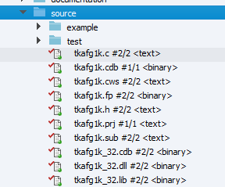

**Header File:**

1. Header:

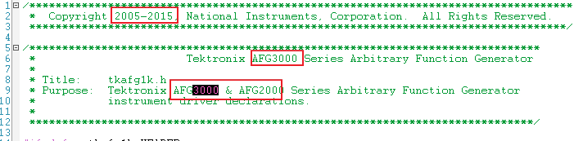

1. This macro name looks weird to me. Why don’t you use upper cases throughout the string?  
   
2. Update the version micros.  
   
3. Remove the AFG3K information and add AFG1K here:  
   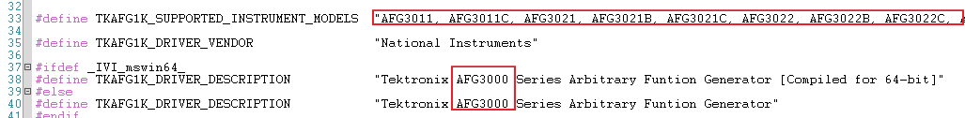

**Source File:**

1. I saw some coding convention issues, please make sure you will run uncrustify tool afterwards.
2. Clean up the include header files: Add <ansi_c.h> and remove <string.h>, <stdio.h>, and <math.h>  
   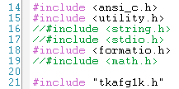
3. Why don’t you create one channel values macro for multiple modulations? E.g. TKAFG1K_VAL_INTERNAL_USER0 for PM, AM, FM and etc… It looks redundancy to me to define USER0 – USER255 multiple times
4. Self test is an unsupported function, add comments in the description  
   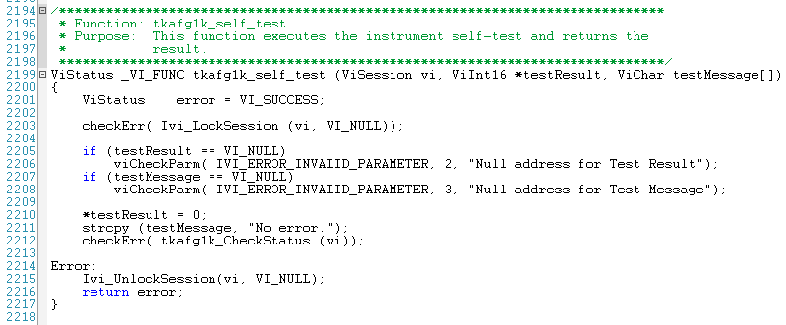
5. Remove commented out code segment.  
   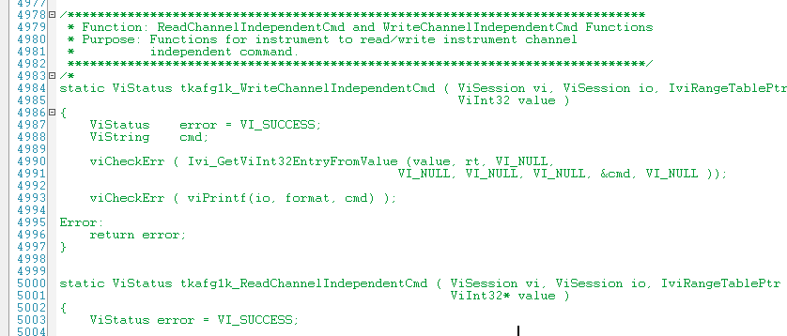  
   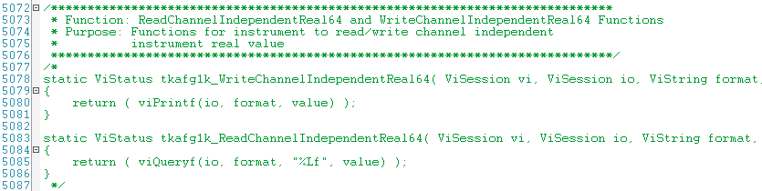  
     
   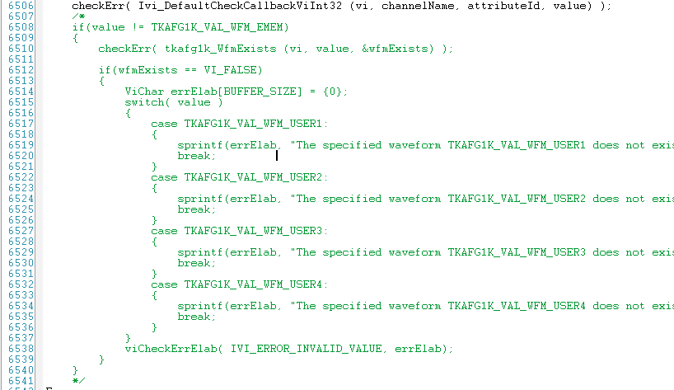
6. Add an end of file mark in the bottom of .c file  
   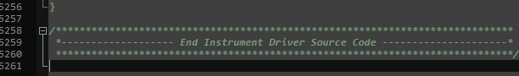

**FP File:**

1. I can still find AFG 3K description in the FP file: Configure PWM Internal By Chan  
   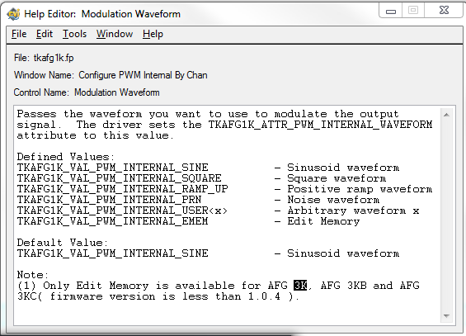

**SDT Result**

1. Does this driver support SoftwareTrigger or not on earth?  
   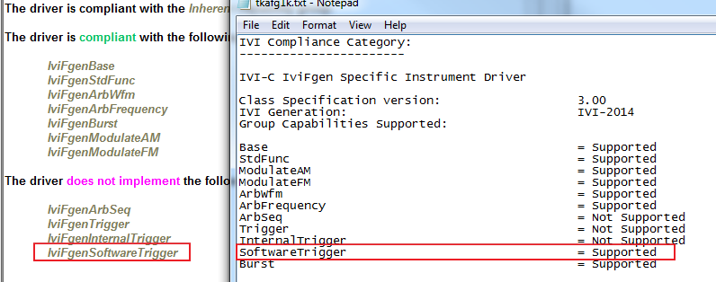

**ERROR: The following constant values defined in the .sub file and the .h file are not consistent:**

**Value:*TKAFG1K_VAL_WFM_RAMP* in Range Table: *attrFuncWaveformRangeTable***

**Value:*TKAFG1K_VAL_WFM_PULS* in Range Table: *attrFuncWaveformRangeTable***

**Value:*TKAFG1K_VAL_WFM_RAMP* in Range Table: *attrWaveformRangeTable***

**Value:*TKAFG1K_VAL_WFM_PULS* in Range Table: *attrWaveformRangeTable***

**Documentation**

1. Do not use TAB.  
   